Club Coaches/ Mentor Profile

General Information
Name: | Rónán McMahon |  |  | 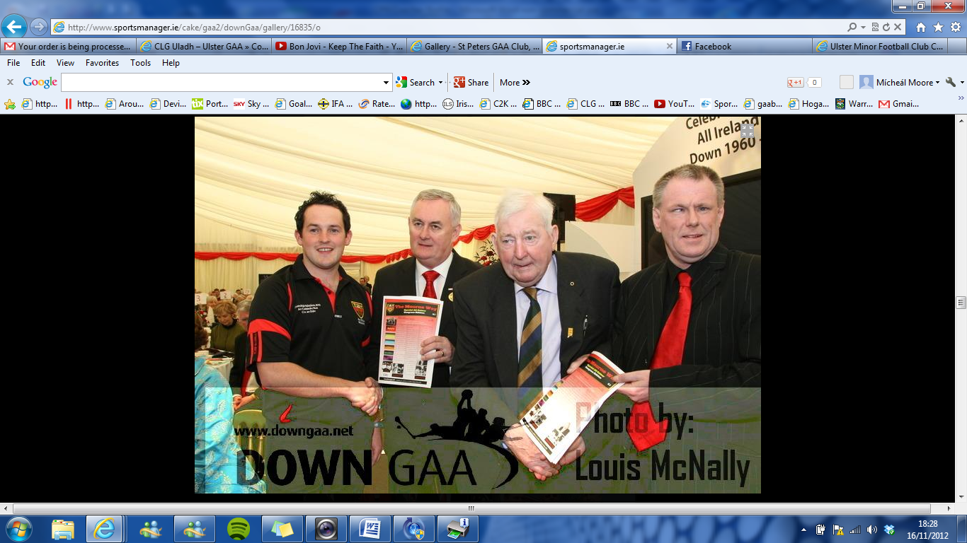
Coaching Role within CPN: | - Coaching and Games Development Officer  - U12 Ladies Manager
Years involved in coaching with CPN | 6 +
Other roles in CPN | Senior Management committee member  Football committee (Vice Chairman)
Other coaching capacities  (Other than CPN) | St Colman’s College PE Teacher
Coaching Related Qualifications
Child Protection Accreditations (Compulsory to work with children as per club policy)
Title |  |  |  | Status
Ulster Council Child Protection Course |  |  |  | Attended
Access NI background checks |  |  |  | Completed
Coaching and Games Awards (minimum of foundation level compulsory to mentor teams as per club policy)
Title |  |  | Awarded by:
Foundation Award |  |  | Down GAA
Level 1 Award (Coach) |  |  | Down GAA
Level 2 Award (Advanced Coach) |  |  | Ulster GAA
First Aid Related Awards
First Aid Course
Defibrillator and CPR Training
Notable Achievements
Coaching Achievements |  | Playing Achievements
Ulster Colleges Dalton Cup 2012 St Colman’s  Ulster Colleges Corn na og 2010 St Colman’s |  | CPN Senior Player (1998 to 2009) Down Intermediate Championship 2001 Down Division 2 League 2001 Ulster Colleges Dalton Cup 1992

